**ABSTRACT:**

The Blood Donor Management System is a web-based platform designed to streamline and facilitate the process of blood donation. The primary objective of this project is to create an efficient system that connects blood donors with blood banks, hospitals, and individuals in need of blood transfusions. The system aims to ensure a steady supply of safe and compatible blood by managing donor information, blood inventory, and donation requests.

This system provides a user-friendly interface where individuals can register as blood donors and provide relevant personal and medical information. Donors can easily search for nearby blood banks or donation centers and schedule appointments to donate blood. The system also allows blood banks to maintain a comprehensive database of donors, including their blood type, donation history, and contact information.

In addition, the Blood Donor Management System enables hospitals and individuals to submit blood requests based on specific blood types and quantities needed. The system automatically matches these requests with suitable donors in the database and sends notifications to potential donors. It also tracks the status of donations, ensuring efficient coordination between donors and recipients.

Furthermore, this system incorporates features to enhance communication and engagement among donors, blood banks, and recipients. It includes functionalities such as sending reminders for regular blood donations, providing updates on urgent blood needs, and expressing gratitude to donors for their contributions.

The implementation of the Blood Donor Management System offers numerous benefits. It optimizes the process of finding and coordinating blood donors, reducing response times and increasing the chances of timely blood transfusions. By centralizing donor information and blood inventory, it improves the overall efficiency of blood banks and enhances the management of scarce resources. Ultimately, this system contributes to saving lives by promoting a sustainable and organized approach to blood donation.

In conclusion, the Blood Donor Management System provides a comprehensive and user-friendly platform for managing blood donations. By leveraging technology to connect donors, blood banks, hospitals, and recipients, this system aims to streamline the blood donation process, ensure a steady supply of blood, and make a significant impact on healthcare systems.

**CHAPTER 1**

**INTRODUCTION  
1.1 Overview**

The Blood Donor Management System is a comprehensive solution designed to streamline the process of blood donation and enhance coordination between donors, blood banks, hospitals, and recipients. With a backend built on Python[Flask] and a front end powered by HTML,CSS. This system leverages modern technologies to provide efficient and user-friendly functionalities.

The primary goal of the Blood Donor Management System is to facilitate the management of donor information, blood inventory, and donation requests. The system allows individuals to register as blood donors, providing essential personal and medical details. It also enables the blood donor management system to maintain a centralized database of donors, including their blood types, donation history, and contact information.

The frontend, developed using HTML5, and CSS offers a seamless and intuitive user experience. It provides features such as donor registration, search functionality to find nearby blood banks, and appointment scheduling for blood donation. The frontend also allows individuals to submit blood requests based on specific blood types and quantities needed.

On the backend, Flask powers the core functionalities of the system. It handles the storage and retrieval of donor information, blood inventory management, and matching donation requests with suitable donors. The Flask framework ensures the security and integrity of the data, while also providing robust APIs for seamless integration with the frontend.

The Blood Donor Management System incorporates advanced features to enhance communication and engagement among donors, blood banks, and recipients. It includes automated notifications to potential donors for urgent blood needs, reminders for regular blood donations, and a feedback mechanism to express gratitude to donors for their contributions.

By combining the power of Flask and HTML5, this system offers a scalable and reliable solution for managing blood donations. It streamlines the process, reduces response times, and improves the overall efficiency of blood banks and healthcare institutions. The Blood Donor Management System aims to make a positive impact on healthcare systems by ensuring a steady supply of safe and compatible blood for those in need.

In conclusion, the Blood Donor Management System, with its backend built on Flask and frontend powered by HTML 5 , provides a comprehensive and efficient solution for managing blood donations. It leverages modern technologies to enhance coordination between donors, blood banks, hospitals, and recipients, ultimately saving lives and making a significant impact on healthcare systems.

**1.2 Background Study:**The concept of Blood Donor Management systems is gaining significant traction worldwide. As the importance of efficient blood donation processes increases, numerous organizations are developing online platforms and systems to streamline the management and coordination of blood donors, blood banks, hospitals, and recipients.

The primary objective of this project is to create a comprehensive Blood Donor Management system that leverages advanced technologies to facilitate the blood donation process. The system aims to provide an intuitive online platform where individuals can easily register as blood donors and access a centralized database of blood banks, hospitals, and donation centers. Through the platform, users can conveniently schedule blood donation appointments and select their preferred location.Similar to e-commerce platforms, the Blood Donor Management system functions as a virtual space on the internet. Users can browse through a catalog of available blood types and quantities, enabling them to make informed decisions. The system incorporates a user-friendly interface and offers features such as a virtual shopping cart, allowing users to select and add desired blood units.

During the checkout process, users are required to provide additional information, including personal details, medical history, and contact information. To ensure data security, the system may request payment information, such as credit card details or relevant billing information. Upon placing a blood donation order, the system generates an email notification to the user, confirming the appointment and providing pertinent details.Furthermore, the Blood Donor Management system includes a feature that allows direct communication between donors and relevant stakeholders. Users can initiate contact with blood banks, hospitals, or recipients to address specific queries or concerns, fostering transparency and engagement within the blood donation ecosystem.In summary, the Blood Donor Management system aims to optimize and streamline the blood donation process through its user-friendly online platform. By leveraging advanced technologies, this system enables individuals to register as donors, browse available blood units, schedule appointments, and engage in direct communication with relevant stakeholders. Ultimately, the system enhances the efficiency of blood donation initiatives while ensuring a seamless and secure experience for all participants.

**1.3 Project Planning:**

In addition to project management, Gantt charts and other scheduling tools are utilized to plan and monitor the progress of the Blood Donor Management system project. The initial step involves determining the intended scope of the project.

Managing a project and developing a Blood Donor Management system entails a considerable amount of effort and numerous variables. It is crucial to effectively manage these processes to establish a solid foundation for a successful blood donation management platform. The project encompasses tasks such as conducting business research, UI/UX design, selecting appropriate technologies and platforms, and making decisions about hosting the system.

Once these processes are summarized, the functional Blood Donor Management system will be ready as the final product. Each individual task's duration is determined and organized into a work breakdown structure. An activity network diagram is employed to identify the critical path by establishing logical connections between tasks. Project management software can be utilized to calculate the slack time in the schedule.

To determine the overall project cost, all the necessary resources are estimated, and the cost of each activity is allocated to the relevant resource. At this stage, the project plan can be refined to align with the project's objectives by adjusting resource allocation and project timeline. Once a consensus is reached on the project strategy, a baseline is established. Throughout the course of the project, progress will be evaluated by comparing it to the initial state.

In conclusion, the project planning phase of the Blood Donor Management system involves utilizing project management techniques such as Gantt charts and scheduling tools. The scope of the project is determined, and tasks are organized into a work breakdown structure. The critical path is identified, and resource allocation and project timeline are adjusted to achieve the project's objectives. A baseline is established, and progress is monitored throughout the project's execution.

**1.4 Purposes:**For the Blood Donor Management system project, the primary purpose is to effectively manage and coordinate all aspects related to blood donation. The system aims to bring together various stakeholders, streamline processes, and leverage technology to enhance the overall blood donation experience. The following are the primary goals of the project:

a. Donor registration and management: The system facilitates the automation of donor registration and management processes. It allows individuals to easily register as blood donors, providing their personal information, medical history, and contact details.

b. Blood inventory management: The project focuses on efficiently managing and tracking the available blood inventory. It ensures accurate and up-to-date information on blood types, quantities, and expiration dates.

c. Donation requests and matching: The system enables hospitals and individuals in need of blood transfusions to submit donation requests. It utilizes algorithms to match these requests with suitable donors based on blood type and availability.

d. Appointment scheduling and reminders: The project includes features to schedule and manage blood donation appointments. It provides automated reminders to donors for regular blood donations, ensuring a consistent supply of blood.

e. Reporting and analytics: The project incorporates reporting and analytics functionalities to generate insights into blood donation patterns, donor demographics, and other relevant metrics. These insights can inform decision-making and improve overall blood donation management strategies.

f. Security and privacy: The Blood Donor Management system prioritizes the security and privacy of donor information. It ensures the use of authorized email accounts and passwords, implementing robust measures to protect sensitive data.

**1.5 Problem Statements:**

Efficiently manage and streamline the blood donation process, ensuring seamless coordination between donors, blood banks, and recipients, while prioritizing the security of donor information.

**1.6 Project Goals:**The data will be stored properly in database, which will help in retrieval information and

better for working.

**1.6.1 Accuracy:**

Ensure precise and reliable management of donor information, blood inventory, and donation requests, ensuring that the system effectively matches compatible donors with recipients, and maintains accurate records of blood types, quantities, and expiration dates.

**1.6.2 Reliability:**

Establish a highly reliable system by ensuring the secure storage and retrieval of donor information, accurate tracking of blood inventory, and seamless coordination of donation requests. The system aims to minimize errors, ensure data integrity, and provide a dependable platform for efficient blood donation management.

**1.6.3 No Redundancy:**

Implement strict measures to prevent duplication of donor information or any other data within the system, ensuring consistency and accuracy of stored data. Reducing redundancy guarantees efficient storage and retrieval of information, streamlining the blood donation process.

**1.6.4 Easy to Operate:**

Design the system to be user-friendly and intuitive, allowing for easy navigation and interaction for all stakeholders involved in blood donation. The system should be developed efficiently within a short time-frame and consider the constraints of the user's limited budget.

**1.6.5 Efficiency:**

Ensure efficient storage and integration of a vast amount of donor and blood inventory data, enabling the system to generate reports seamlessly. Data integrity ensures accurate and swift report generation, enhancing the overall efficiency of the blood donation management process.

**1.6.6 Effectiveness:**

Implement proactive management actions to enhance performance and ensure prompt response to donation requests. The system effectively addresses the needs of customers, providing timely and efficient responses, thereby improving the overall effectiveness of the blood donation management process.

**CHAPTER 2**

**LITERATURE REVIEW**

Existing studies have identified various factors that impact individuals' intentions to donate blood. These factors may include altruism, social norms, perceived benefits, convenience, trust, and perceived risks. Researchers have highlighted the importance of understanding donors' motivations and barriers to blood donation, as well as the role of effective communication strategies in promoting and sustaining donor engagement.

Moreover, studies have emphasized the significance of efficient blood inventory management, accurate matching of donors and recipients, and the use of technology to streamline the blood donation process. Researchers have explored the role of information systems, donor databases, and communication platforms in facilitating communication and coordination among stakeholders.

Additionally, the literature review will examine the psychological aspects of blood donation. It will explore the decision-making process behind individuals' intentions to donate blood, including the role of social influence, personal values, and emotional factors.

By synthesizing previous research, the literature review aims to provide insights into the key factors, challenges, and best practices in the management of blood donor systems. It will contribute to a better understanding of the factors that influence individuals' willingness to participate in blood donation and guide the development of an effective Blood Donor Management System.

**2.1 System Information:**

The Blood Donor Management System is a comprehensive software designed to facilitate the management and coordination of blood donation processes. The system provides the following system information:

a. User-Friendly Interface: The system offers an intuitive and user-friendly interface, allowing users to navigate through the functionalities easily.

b. Database Management: The system efficiently manages a centralized database of donor information, blood inventory, and donation requests.

c. Search Functionality: The system incorporates a robust search engine, enabling users to quickly search and retrieve relevant donor or blood inventory information.

d. Customizable Look and Feel: The system provides a customizable interface, allowing users to tailor the visual elements to their preferences and create a personalized environment.

e. Integration and Accessibility: The system ensures seamless integration with other healthcare systems and provides accessibility to authorized personnel, such as blood bank staff, hospital administrators, and healthcare professionals.

f. Security and Data Privacy: The system prioritizes the security and privacy of donor information, implementing measures to safeguard sensitive data and comply with data protection regulations.

g. Reporting and Analytics: The system generates comprehensive reports and analytics, offering insights into blood donation trends, donor demographics, and other relevant metrics to support decision-making and strategic planning.

h. Communication and Notifications: The system facilitates communication and notifications between stakeholders, enabling prompt updates on blood requests, donation appointments, and gratitude expressions to donors.

**2.2 Feasibility:**

In the case of the Blood Donor Management System, it is important to assess the feasibility before proceeding. The two key techniques for conducting a feasibility study are:

a. Technical Feasibility: This involves evaluating whether the proposed system can be developed and implemented using the available technology and resources. It assesses factors such as compatibility with existing systems, scalability, required infrastructure, and technical expertise needed for development and maintenance.

b. Economic Feasibility: This assesses the financial viability of implementing the system. It involves analyzing the costs associated with development, implementation, training, and ongoing maintenance, as well as estimating potential benefits and returns on investment. Economic feasibility considers factors such as cost-effectiveness, profitability, and the organization's budgetary constraints.

**2.3 Technical Feasibility:**

The Blood Donor Management System is technically feasible as it is reasonably straightforward to gather the necessary resources for system development and maintenance. The required resources, including hardware, software, and technical expertise, are readily available to support the creation and maintenance of the system. The technologies and tools needed for database management, user interface development, and communication integration are accessible and can be effectively utilized for the development and implementation of the Blood Donor Management System.

**2.4 Economic Feasibility:**

The Blood Donor Management System is economically feasible as it involves minimal costs for development and implementation. The organization can utilize existing resources and set up a development environment under the guidance of a qualified individual, resulting in cost savings. The system's efficient use of resources ensures that ongoing expenses are kept to a minimum. Considering the cost-effectiveness and the potential benefits it brings, the Blood Donor Management System has a promising and sustainable future

**2.5 Deliverables:**

The deliverables of the Blood Donor Management System are the tangible and intangible outcomes and products that result from the project. They include:

1. Blood Donor Database: A centralized and secure database that stores comprehensive information about blood donors, including personal details, medical history, blood type, and contact information.
2. Blood Inventory Management System: A system that tracks and manages the available blood inventory, including blood types, quantities, expiration dates, and storage conditions.
3. Donation Request and Matching System: A feature that enables hospitals and individuals in need of blood transfusions to submit donation requests, which can be efficiently matched with suitable donors based on blood type compatibility and availability.
4. Appointment Scheduling and Reminder System: A functionality that allows donors to schedule blood donation appointments conveniently and receive automated reminders for regular donations.
5. Reporting and Analytics: Reporting capabilities that provide insights into blood donation trends, donor demographics, inventory levels, and other relevant metrics, supporting decision-making and strategic planning.
6. Communication and Notification Platform: A platform that facilitates effective communication and notifications between donors, blood banks, hospitals, and recipients, ensuring prompt updates on blood requests, donation appointments, and expressions of gratitude.
7. User-Friendly Interface: A visually appealing and intuitive user interface that ensures ease of navigation and accessibility for all stakeholders involved in the blood donation process.
8. Training and Support Materials: Documentation, user manuals, and training resources to assist users in effectively utilizing the system and performing their roles within the blood donation management process.

**2.5.1 When to use the Direct Dependencies:**

a. The requirements are well understood, specific, and fixed: Direct Dependencies can be suitable when the project requirements are clear and unlikely to change significantly throughout the development process. This allows for a focused and efficient implementation of the Blood Donor Management System.

b. When it's necessary to implement fresh adjustments: Direct Dependencies can be advantageous when the need for incorporating new adjustments or updates is anticipated. It allows for flexibility in adapting the Blood Donor Management System to meet changing requirements or emerging needs.

c. When expedient production is more important than product quality: Direct Dependencies can be appropriate when there is a higher priority placed on quickly producing a functional Blood Donor Management System, rather than focusing extensively on fine-tuning or optimizing the product quality.

d. The deadline for clients to change the project's scope: Direct Dependencies can be useful when the project has a fixed scope and clients are restricted from making significant changes after a certain deadline. It allows for a more controlled and predictable development process.

e. Its uses include time-sensitive applications, and its product definition is stable: Direct Dependencies are applicable when the Blood Donor Management System needs to serve time-sensitive purposes and the product requirements and specifications are well-defined and unlikely to undergo significant changes.

f. Technology is comprehended: Direct Dependencies are appropriate when the project team has a good understanding of the technology and tools required for developing the Blood Donor Management System. This ensures efficient implementation and utilization of the necessary technology stack.

g. No requirements are ambiguous: Direct Dependencies can be employed when all project requirements are clearly defined, leaving no room for ambiguity or confusion. This facilitates a straightforward development process.

h. There are plenty of free resources with the necessary expertise: Direct Dependencies can be advantageous when there is easy access to abundant free resources or expertise needed for developing the Blood Donor Management System, reducing the project's costs and potential resource constraints.

i. The task is not long: Direct Dependencies can be suitable for shorter-term projects, where the timeline for developing the Blood Donor Management System is relatively compressed, allowing for a more direct and efficient implementation approach

**CHAPTER 3**

**METHODOLOGY**

3.1 Design:

The design of the Blood Donor Management System includes the following sections:

1. Search System: Allows users to search for specific blood donors based on criteria such as blood type, location, and availability.
2. Registration and Profile System: Enables donors to register and create their profiles, providing personal information, medical history, and contact details.
3. Donation Request System: Allows users and individuals in need of blood transfusions to submit donation requests, specifying blood type requirements and other relevant details.
4. Donation Request : Facilitates the scheduling of blood donation for donors, ensuring efficient coordination between donors and donation centers.
5. Communication System: Provides a platform for communication between blood donors, hospitals, and recipients, allowing them to exchange messages, address queries, and discuss donation-related matters.
6. Location System: Integrates location-based services to help users find nearby blood banks, donation centers, and hospitals.
7. Favorites System: Enables users to save and manage their favorite blood donors or preferred donation centers for easy access and future reference.
8. Viewing System: Allows users to view donor profiles, donation history, and relevant information about blood banks .

**3.2 User Characteristics:**

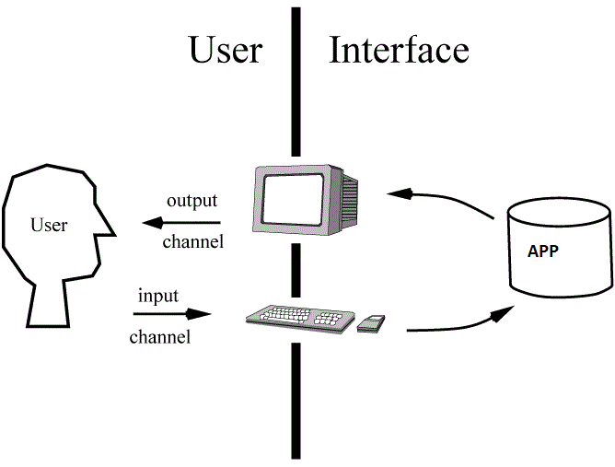

**3.3 UML Diagrams:**

This UML Diagram Shows the Admin for the Owner of the blood Donor management system and Website that will be very easy and convenient for the Owner.

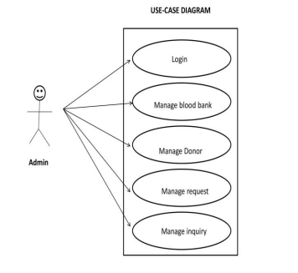

**CHAPTER 4**

**EXPERIMENTAL WORK**

Practical Work

When selecting software, special consideration should be given. This portion is really helpful because it includes the implementation of an actual system and writing code to carry it out all in performance for the new information system. Server-side programming is the top focus while developing Web applications.

4.1. PyCharm Professional

4.2. Flask

4.3 HTML5

4.4 CSS BOOTSTRAP

4.5 Javascript

**4.1 PyCHARM Professional:**

PyCharm Professional is an advanced Python integrated development environment (IDE) designed to boost productivity and streamline Python programming. It offers a wide range of features such as intelligent code completion, debugging tools, version control integration, and support for popular Python web frameworks like Django and Flask. The IDE also includes tools for test-driven development, code refactoring, and database integration. PyCharm Professional provides a user-friendly interface and collaboration features for seamless team work. Overall, it is a powerful tool for professional Python developers, enhancing coding efficiency and facilitating project management.

**4.2 Flask:**

Flask is a lightweight and flexible web framework written in Python. It allows developers to build web applications quickly and efficiently with minimal boilerplate code. Flask follows the model-view-controller (MVC) architectural pattern and provides a simple yet powerful API for handling HTTP requests, routing, and rendering dynamic web pages.

With Flask, developers can easily create routes to define the URL endpoints of their application and associate them with functions that handle the requests. It supports various HTTP methods like GET, POST, PUT, and DELETE, allowing developers to implement RESTful APIs or traditional web applications.Flask also offers a templating engine that enables the creation of dynamic HTML pages. Templates can be easily integrated with Python code, allowing for dynamic content generation and seamless data presentation. Additionally, Flask provides support for form handling, file uploads, and cookie management, making it well-suited for building interactive web forms.

One of the strengths of Flask is its extensibility. It follows a modular design, allowing developers to easily integrate third-party extensions and libraries to add functionalities such as database integration, user authentication, and caching. Flask's ecosystem includes a wide range of extensions, providing solutions for various application requirements.

The simplicity and flexibility of Flask make it a popular choice for building small to medium-sized web applications, RESTful APIs, and prototypes. It has a gentle learning curve, making it accessible to both beginners and experienced Python developers.Flask Documentation is comprehensive, and its active community ensures ongoing support and resources for developers.

**4.3 HTML:**

HTML5 is the latest version of the Hypertext Markup Language, used for creating web pages and applications. It introduces new features and improvements to enhance the functionality and interactivity of websites. Some key highlights of HTML5 include:

Multimedia Support: HTML5 includes native support for audio and video playback, eliminating the need for additional plugins like Flash.

Canvas Element: It provides a powerful platform for creating dynamic graphics and animations using JavaScript, allowing developers to build interactive visual experiences.

Semantic Elements: HTML5 introduces semantic elements such as <header>, <nav>, <article>, and <footer>, which give structure and meaning to different sections of a web page, enhancing accessibility and SEO.

APIs: HTML5 offers a range of APIs that enable web applications to access device features and perform advanced functions. Examples include Geolocation, Web Storage, Web Workers, and Drag and Drop.

Improved Forms: HTML5 introduces new input types and attributes, making it easier to validate and handle user input. This simplifies form validation and enhances the user experience.

Responsive Web Design: HTML5 provides better support for creating mobile-friendly websites through features like media queries, allowing developers to create designs that adapt to different devices and screen sizes.

Overall, HTML5 brings exciting enhancements to web development, making it easier to create multimedia-rich, interactive, and mobile-friendly websites and applications.

**4.4: CSS BOOTSTRAP:**

Bootstrap is a popular CSS framework that provides a collection of pre-designed components, layouts, and utilities for building responsive and visually appealing websites. With Bootstrap, developers can streamline the design process and create modern, mobile-first web pages with minimal effort.

One of the key advantages of using Bootstrap is its extensive library of CSS classes. These classes enable developers to easily apply styling and formatting to HTML elements, making it simple to create consistent and visually appealing designs across different pages. The grid system offered by Bootstrap allows for the creation of responsive layouts that adapt to various screen sizes, ensuring a seamless experience on desktops, tablets, and smartphones.

Bootstrap also provides a wide range of pre-built components, including navigation menus, buttons, forms, cards, modals, and more. These components are designed to be easily customizable and can be integrated into websites with minimal coding. By leveraging these ready-to-use components, developers can save time and effort while maintaining a professional and polished look for their web projects.

Additionally, Bootstrap offers a variety of JavaScript plugins that enhance the functionality of web pages. These plugins provide features like carousels, dropdown menus, tooltips, and modal dialogs, further expanding the possibilities for interactive and engaging user experiences.

By using Bootstrap, developers can create responsive and visually appealing websites quickly and efficiently. The framework's flexibility, extensive documentation, and active community support make it a go-to choice for web developers looking to build modern and stylish websites.

**4.5 JavaScript:**

JavaScript is a versatile and widely-used programming language that powers dynamic and interactive elements on websites. As a client-side scripting language, JavaScript allows developers to add functionality and interactivity to web pages, making them more engaging and responsive.

With JavaScript, developers can manipulate HTML elements, modify content, handle user interactions, and dynamically update page elements without requiring a full page reload. It provides a wide range of built-in functions and objects that enable tasks such as form validation, animations, and event handling.JavaScript is supported by all major web browsers, making it a universal language for web development.

**4.6 Integration Analysis:**

An SRI method known as "integrated analysis" identifies new areas of danger or chance and

applies those findings into financial analysis help improve financial analysis therefore

ultimately improve investing decision-making. Check the performance of the entire APP after

completing all works that make up the Online services providing Application, paying special

attention to the interface and we can check and edit (input/output parameters) for a

Application.

**4.7 Interface Analysis:**

In order to find flaws that may had been included into the program interface and incorrect

assumptions regarding the interfaces or interface evaluation was carried out. All buttons were examined to ensure they are pointing at the correct location. For instance, the programmer made sure that when a customer clicked on the get appointment option, the appointment details would begin. Additionally, a user’s interface study was done to make sure that all problem messages are brief and opened promptly at the appropriate times. Language interaction evaluation was also done to make sure that a specific error message is provided so the user may quickly fix the error.

**4.8 System Analysis:**

System evaluation is a set of experiments whose main objective is to put the final system through its paces. In other words, it guarantees that an APP that has been developed and tested independently will function well when incorporated into a bigger system. To determine whether the APP of Online Service could perform all of its duties, several tests were run. Thiswill guarantee that System carries out its designated tasks without a hitch.

To meet the needs of the cloud Service APP, a few structural examinations were conducted.

The testing which run are as listed below:

a. Usability Analysis

b. Analyzes usability issues and the user factor.

c. Security Evaluation

d. A study of accessibility for maintenance.

**4.9 Acceptance Analysis:**

The last step in the website evaluation process is acceptability analysis, often known as

customer analysis. Customers will actively participate in the analysis of the system to make

sure it satisfies their needs. This analysis's main goal is to determine whether the Online

Services App has met the needs of its users.

**4.10 Implementation:**

Converting system requirements into a usable program is the first stage of WebAPP development.

This is the act of deploying a program in an organization and it nearly always incorporates

Web APP design and installations processes.

**CHAPTER 5**

**Results & Discussion**

**5.1 Functionality:**

a. Home Screen

b. Dashboard

c. Donor Search

d. List Of Donors

e. About Us

f. Contact Us

g Request Blood

h. View Campaign

i. Update Personal details

**a. Home Screen:**

This is the Login page of the Blood Donor Management System that is based on the Web.

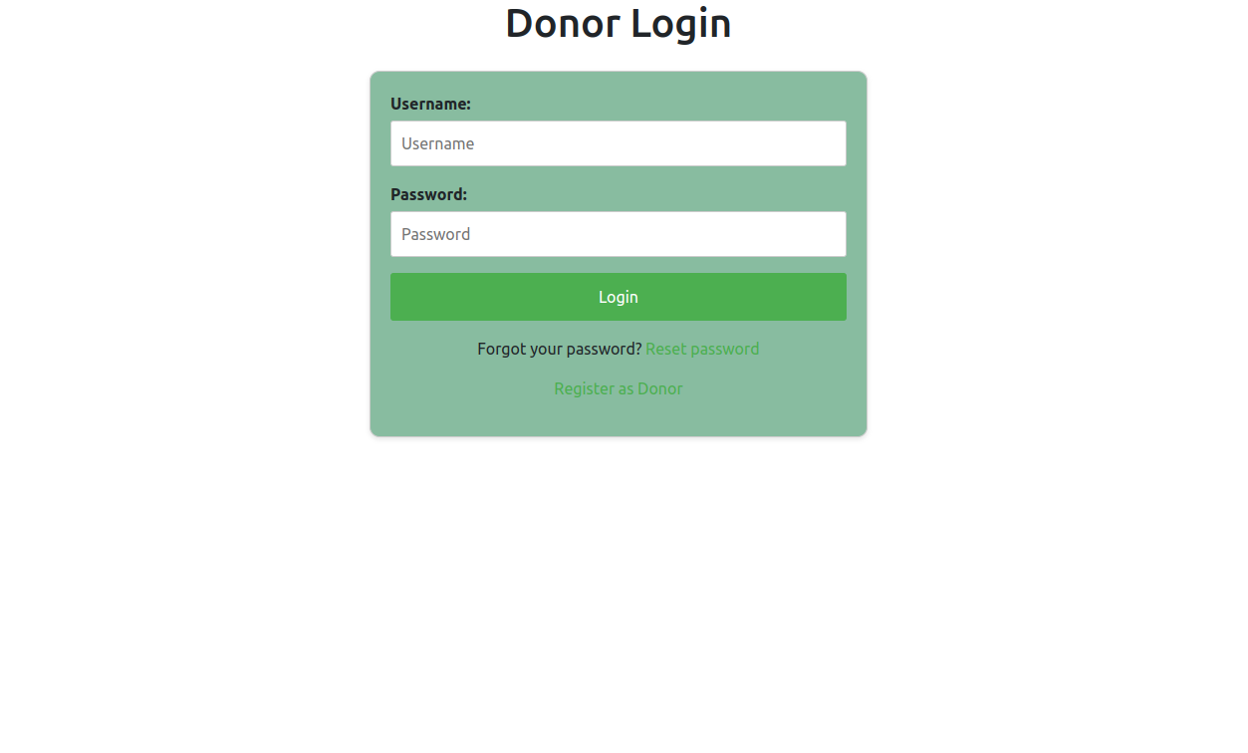

**b. Registration:**

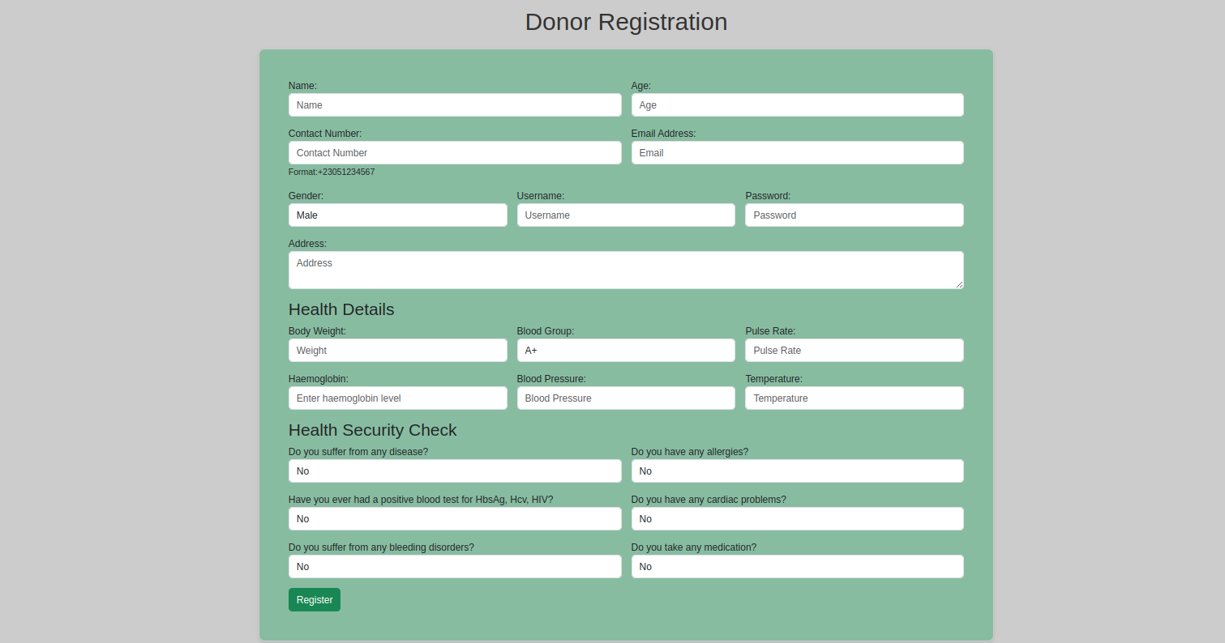

**c. Dashboard:**

This is the Dashboard of the Blood Donor management system that will appear when a user login.

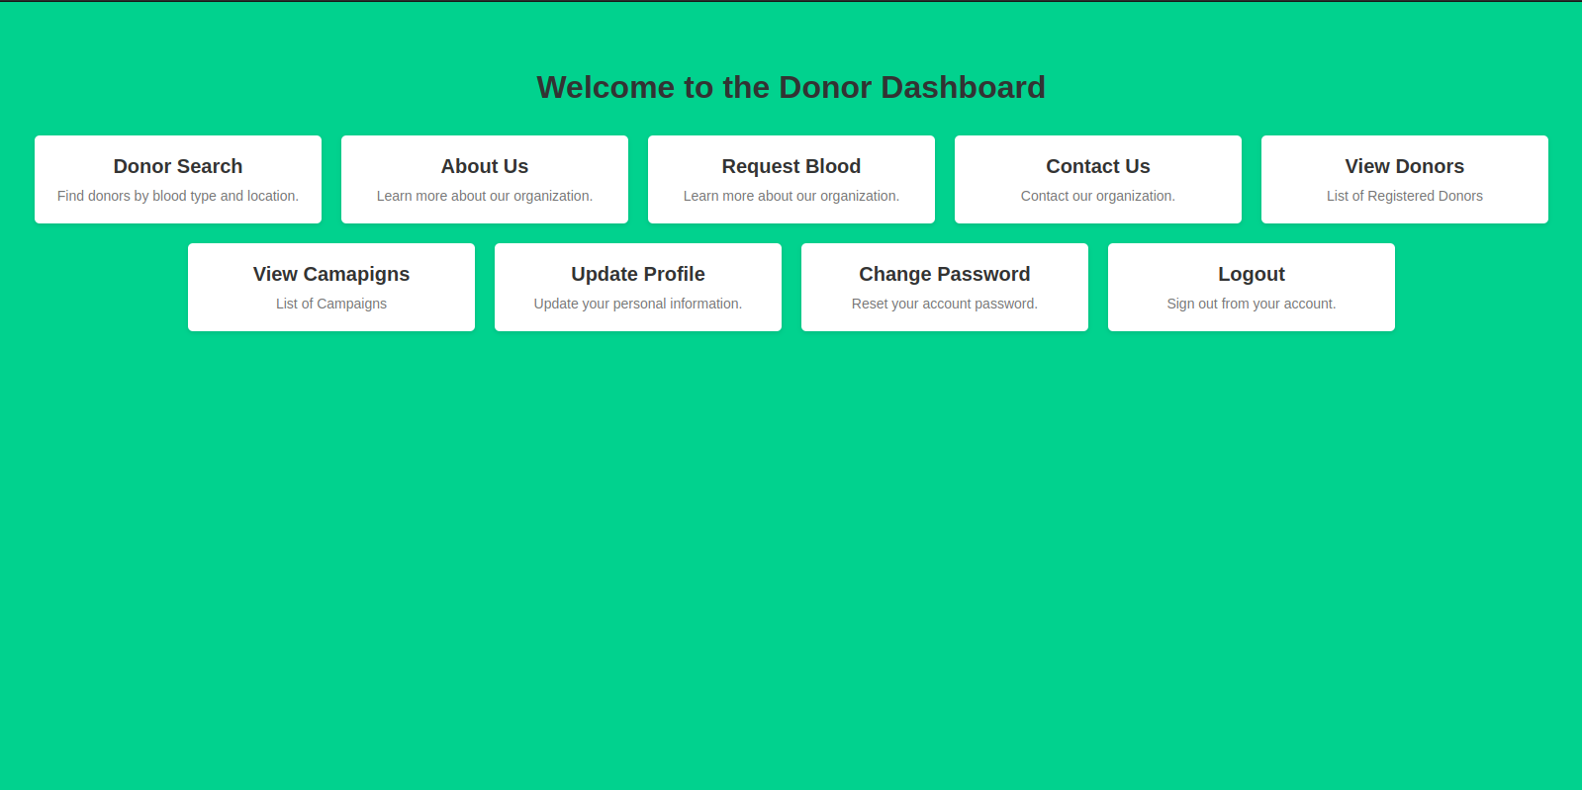

**d. Donor Search:**

In the donor search, you can search the donor by blood groups.

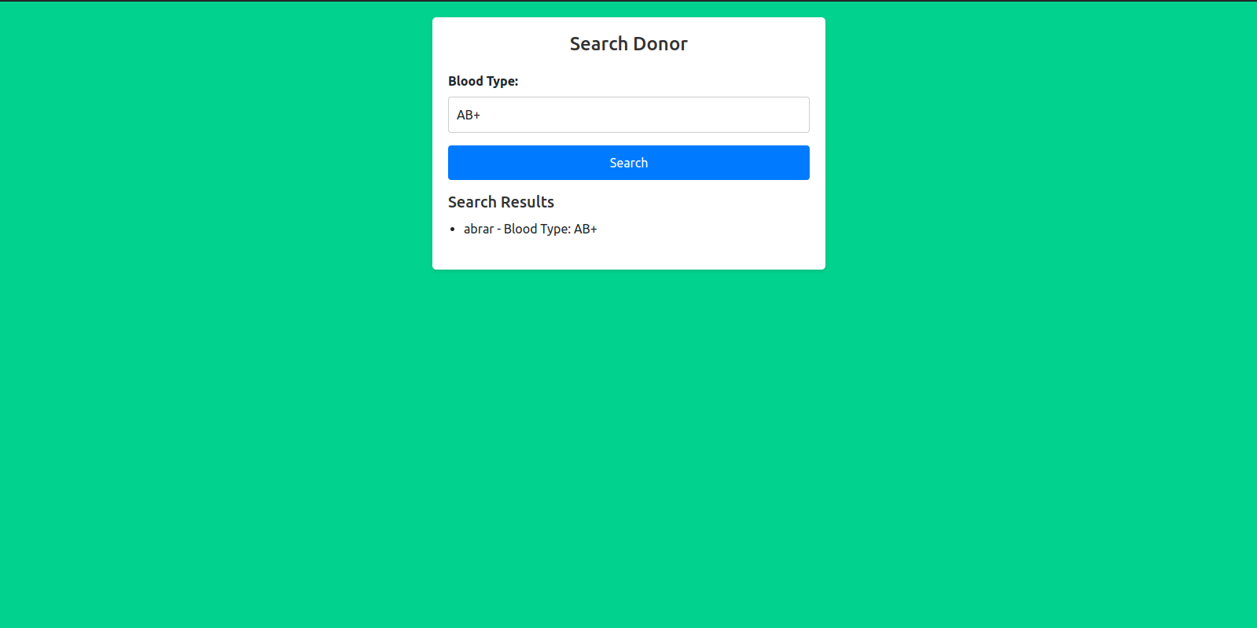

**e. List Of Donors:**

This is the screen that showing how we can see list of donors and their contact info

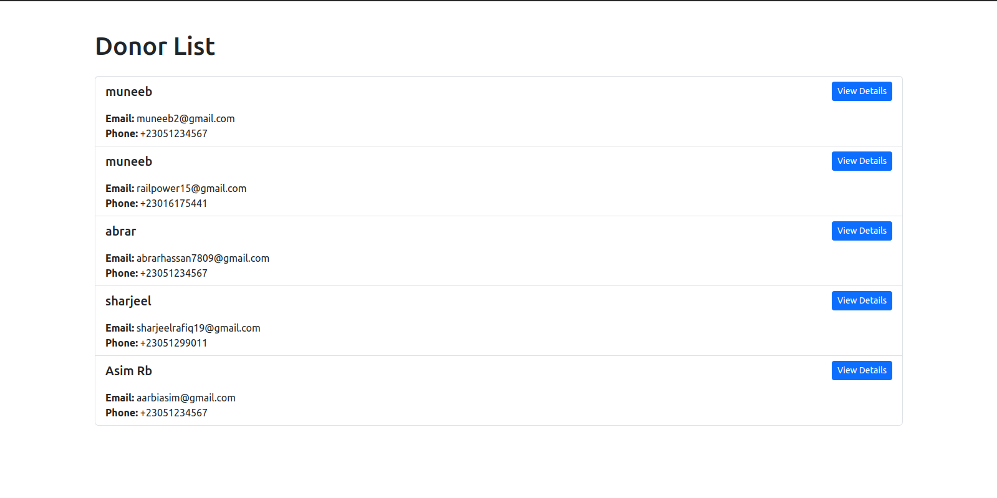

**f. About Us:**

This is the screen where there is a detail about the donors who can donate blood.

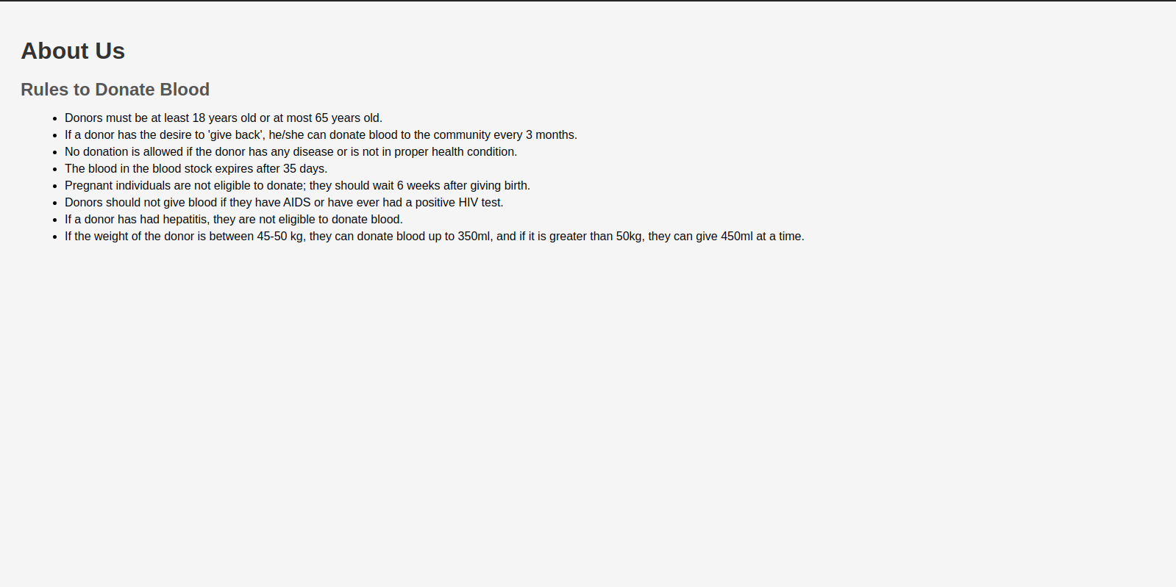

**g. Contact Us:**

In this screen user can submit the form and the response will be submitted to admin mail.

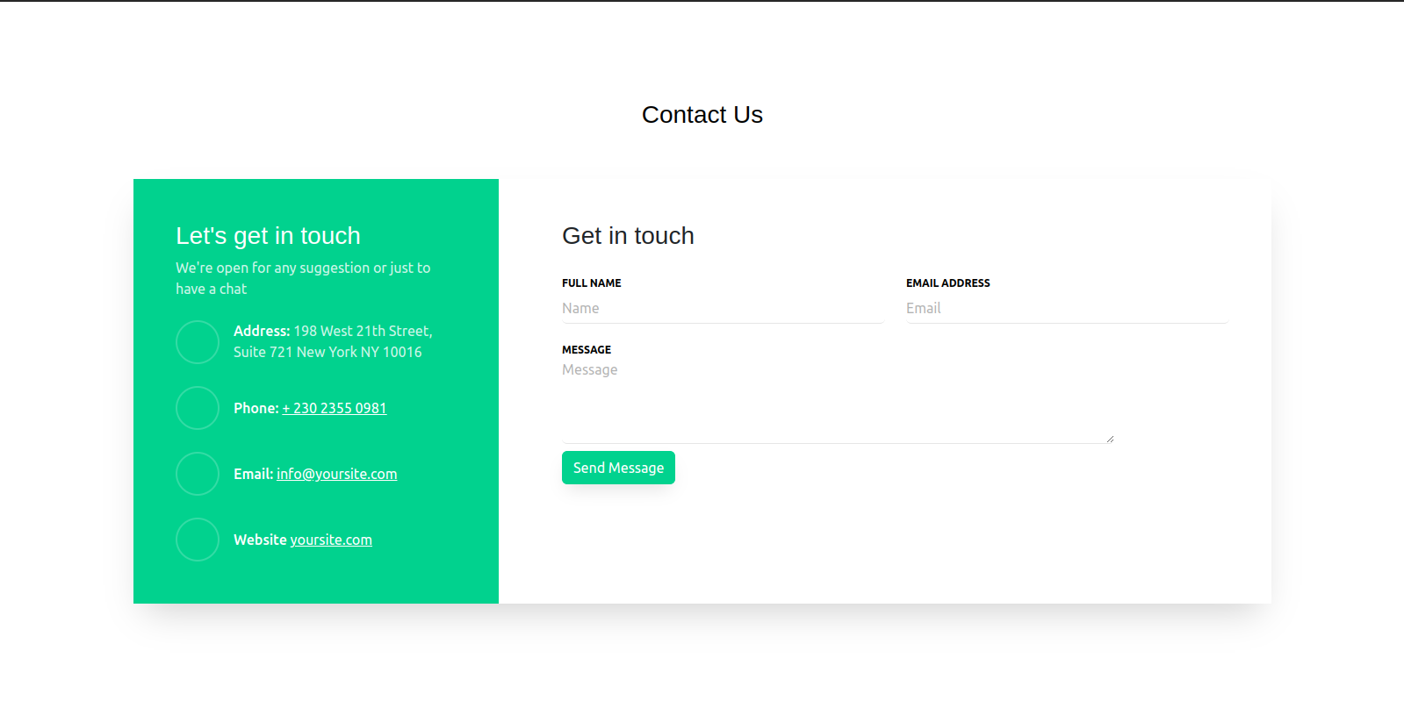

**h. Request Blood:**

Donors can request blood from the request blood screen.The request will be submitted to Admin.

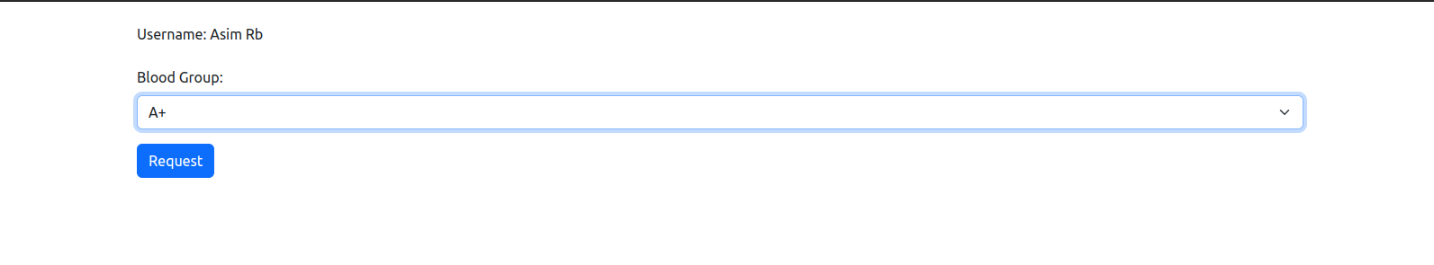

**i. View Campaign:**

The donors can view Campaign details from the view campaign option that is present in the dashboard and they have also been sent invitations via mail.



**j. Update Personal details:**

The donors can update their own personal necessary details from update profile screen.

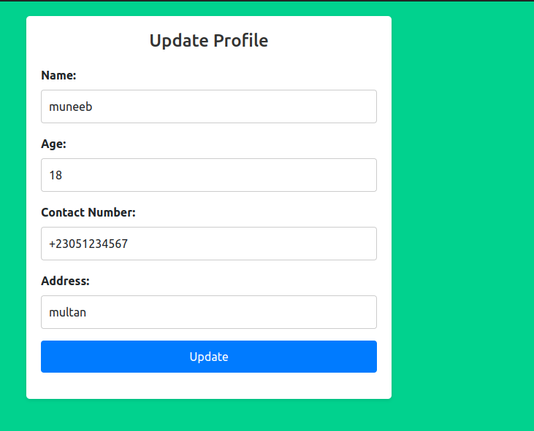

User can also change its password from the forget password that is also present in its dashboard.

**Admin Functionality:**

For the Admin side admin needs to change the routes that are shown above he needs to go towards the admin register side and after successful registration, he will be redirected towards the admin login page which is the main screen of it.

**Admin Registration:**

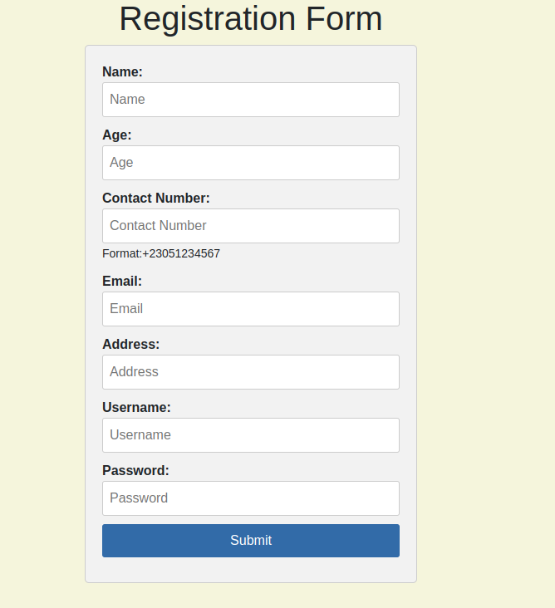

**Admin Login:**

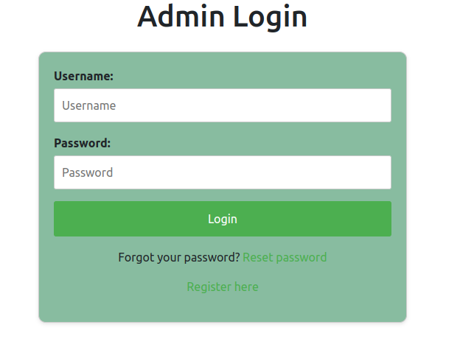

**Admin Dashboard:**  
 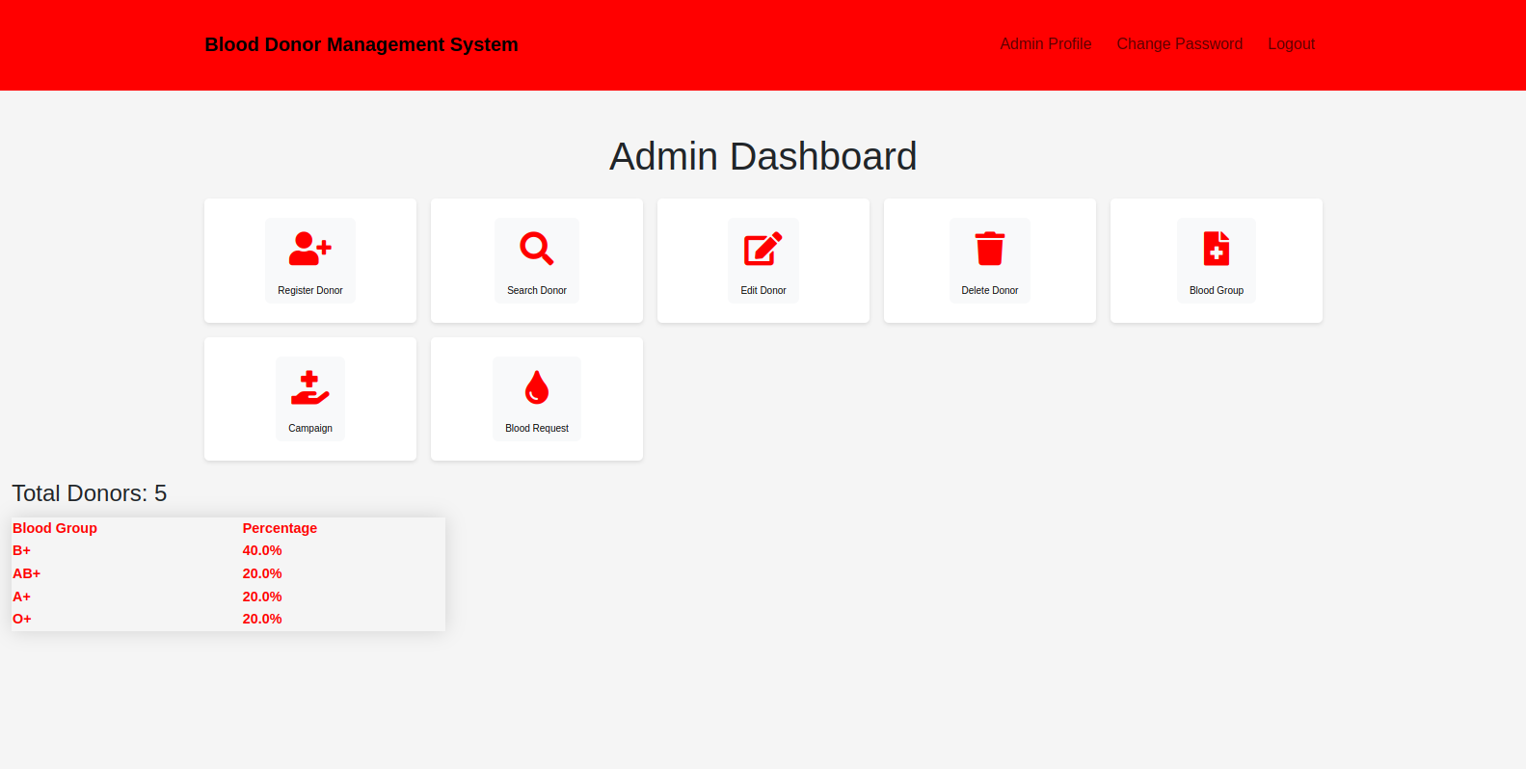

**Donor Registration :**

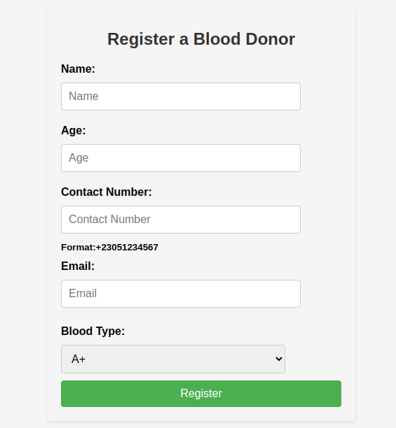

**Edit Profile Of Donors:**

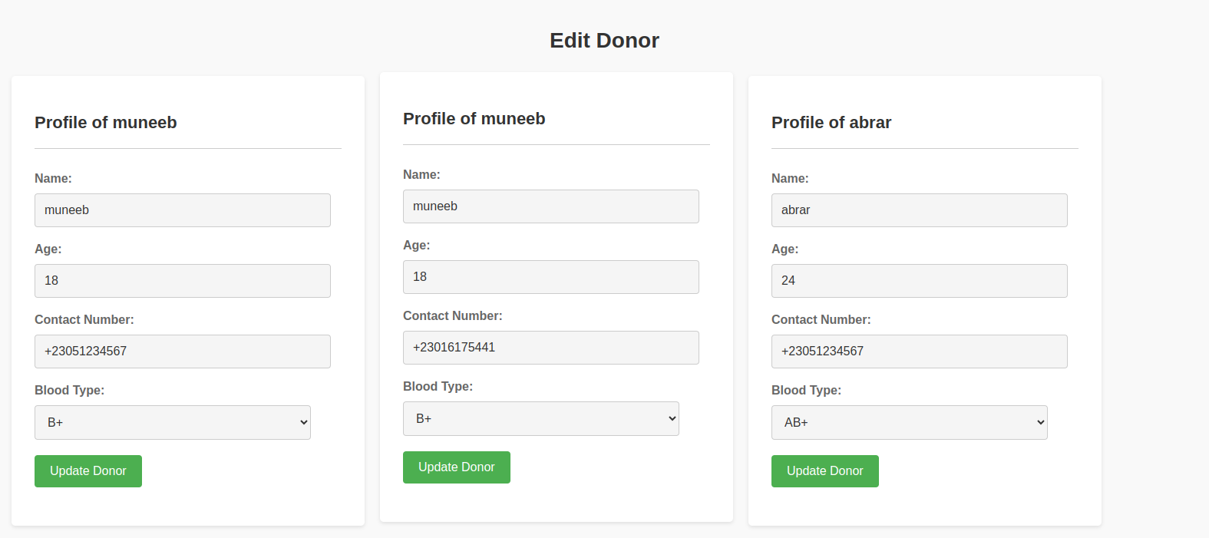

**Delete Donor:**

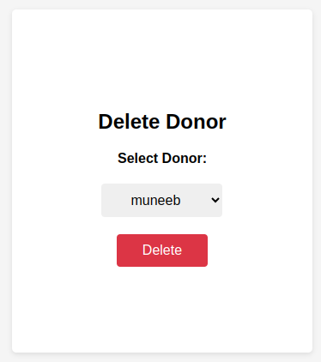

**Blood Group Management:**

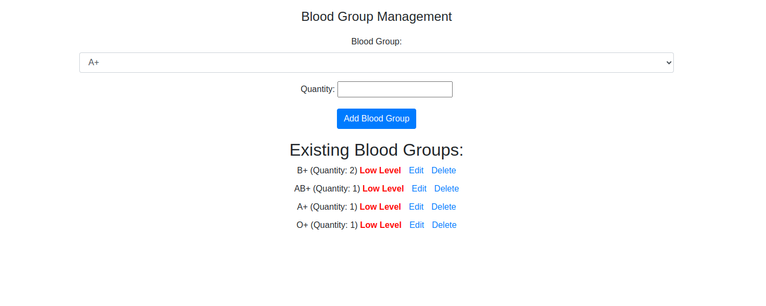

**Campaign Creation:**

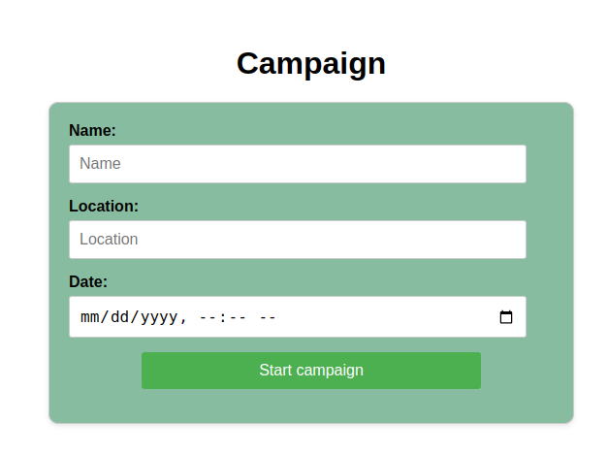

**Blood Requests Shown To Admin:**

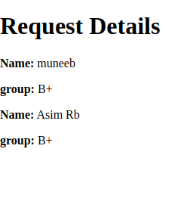

**Admin Profile:**

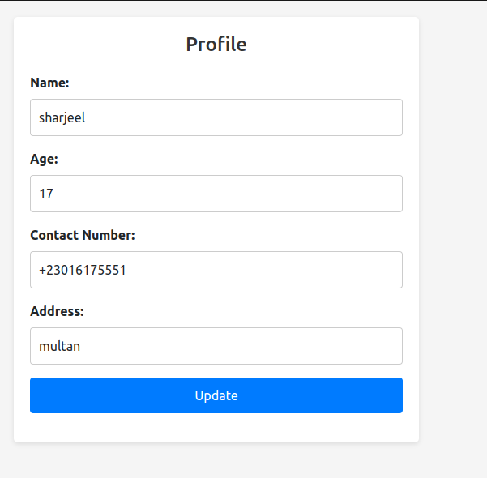

**CHAPTER 6**

**CONCLUSION:**

The development of the web-based Blood Donor Management System represents a valuable contribution to humanity, as it addresses the need for an efficient and organized platform for blood donation. This system consists of two main components: the admin side and the donor side, each offering multiple options and functionalities to streamline the blood donation process.

The system's admin side provides numerous advantages, such as the ability to manage various categories and sub-categories, ensuring data security and optimizing performance. Administrators can efficiently handle tasks such as appointment scheduling and donor selection, reducing time-consuming processes and improving overall efficiency. The user-friendly interface and intuitive functionalities make it easier for administrators to coordinate and manage blood donation activities.

On the donor side, the system offers a range of features that enhance accessibility and convenience. Donors can easily navigate the platform and access information about blood donation. They can schedule appointments, update their personal details, and track their donation history. The system prioritizes user privacy and confidentiality, ensuring the security of donor information.

By implementing the Blood Donor Management System, the R&D department has contributed to advancing blood donation practices, saving lives, and supporting healthcare institutions. The successful completion of this project represents a significant milestone in leveraging technology to improve society and facilitate the life-saving process of blood donation.